**Assessment type:** Test1 calculator allowed **Name: _____________________**

To be completed in class under test conditions

**Task weighting:** 12% of the school mark for the Semester **Mark ____________/32**

**______________________________________________________________________________**

**1** Find the perimeter of the following shape.

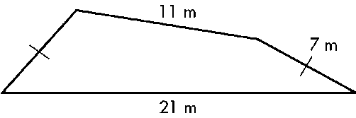

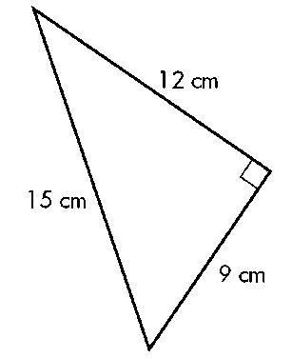**2** Find the area of the following figure.

**3** Find the volume of the following solid.

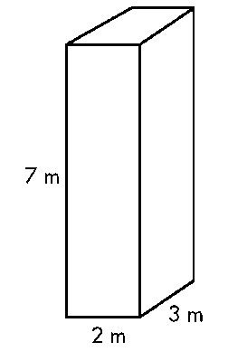

**4** Find the volume of the following solid.

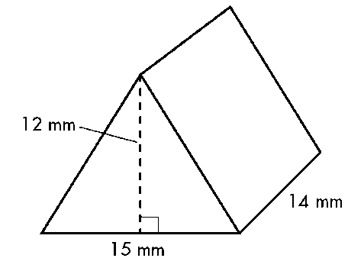

**5** The maximum heart can be calculated by the following formula.

Maximum Heart Rate (MRT) = 208 – 0.7 x your age

1. What would be the maximum heart rate for a 20 year old?
2. What happens to the people’s maximum heart rate as they get older?
3. How much does a person’s MHR change over every 10 year period?

**6** If one kilogram of apples costs $4.79, calculate the following?

1. How much would 1.8 kilograms cost?
2. What would 780 grams cost?
3. How many kilograms of apples can you buy for $20.00?

**7**

Darren’s house has lawn at the front. The area of the lawn is 150 m2. Darren wants to fertilise the lawn and needs to calculate how much fertiliser is needed. He finds out that the recommended rate of application is 30–50 g per square metre. He decides to use 40 g per square metre.  
  
How much fertiliser will he need? Give the answer in kilograms.

**8**

Sean and Fiona are a couple with two small children. They have fenced the back of their suburban property so that their children can play there safely. A plan of the area is shown below:

Sand pit

Vegetable garden

Lawn

House

Scale: 1cm represents 1m

**D**

**C**

**A**

**B**

• the area is the rectangle that is marked ABCD

• the area has a vegetable garden and a sandpit

• the rest of the area is lawn.

• the plan is drawn to scale—1 centimetre represents 1 metre.

1. On the plan, write the real-life dimensions of:
   1. the sand pit
   2. the vegetable garden
   3. the rectangle ABCD
2. Calculate the real-life area of:
   1. the sand pit
   2. the vegetable garden
   3. the lawn

**Solutions**

**______________________________________________________________________________**

**1** Find the perimeter of the following shape.



**46m ✓**

**2** Find the area of the following figure.

**A = 0.5 x 9 x 12**

**= 54 cm2 ✓✓**

**3** Find the volume of the following solid.



**V = 2 x 3 x 7**

**= 42 m3 ✓✓**

**4** Find the volume of the following solid.



**V = (0.5 x 15 x 12) x 14**

**= 1260 mm3 ✓✓✓**

**5** The maximum heart can be calculated by the following formula.

Maximum Heart Rate (MRT) = 208 – 0.7 x your age

1. What would be the maximum heart rate for a 20 year old?

**MHR = 208 – 0.7 x 20 = 194 beats ✓✓**

1. What happens to the people’s maximum heart rate as they get older?

**It gets less ✓**

1. How much does a person’s MHR change over every 10 year period?

**0.7 x 10 = 7 beats ✓✓**

1. If one kilogram of apples costs $4.79, calculate the following?
2. How much would 1.8 kilograms cost?
   1. **1.8 = 8.622 kg** ✓✓
3. What would 780 grams cost?
   1. **4.79 = $3.74** ✓✓ **(1mk if not rounded to nearest cent)**
4. How many kilograms of apples can you buy for $20.00?

**20 ÷ 4.79 = 4.175 kg ✓✓**

**7**

Darren’s house has lawn at the front. The area of the lawn is 150 m2. Darren wants to fertilise the lawn and needs to calculate how much fertiliser is needed. He finds out that the recommended rate of application is 30–50 g per square metre. He decides to use 40 g per square metre.  
  
How much fertiliser will he need? Give the answer in kilograms.

**150 x 40 g ✓= 6000 g ✓= 6 kg ✓**

**8**

Sean and Fiona are a couple with two small children. They have fenced the back of their suburban property so that their children can play there safely. A plan of the area is shown below:

Sand pit

Vegetable garden

Lawn

House

Scale: 1cm represents 1m

**D**

**C**

**A**

**B**

• the area is the rectangle that is marked ABCD

• the area has a vegetable garden and a sandpit

• the rest of the area is lawn.

• the plan is drawn to scale—1 centimetre represents 1 metre.

1. On the plan, write the real-life dimensions of:
2. the sand pit  
    **2 m x 2 m (✓ value, ✓units)**
3. the vegetable garden  
    **3 m x 2 m ✓**
4. the rectangle ABCD  
    **14 m x 12 m✓**
5. Calculate the real-life area of:
6. the sand pit

**4m2 (✓ value, ✓units)**

1. the vegetable garden

**6m2** ✓

1. the lawn

**(168✓ - 4–6) ✓= 158 m2 ✓**